Infosys Springboard Virtual Internship 6.0
Completion Report
Team Details <Do not mention any personally identifiable information like email ID, institute details, mobile phone number etc.>
Batch Number: 13 – WellBot Global Wellness Assistant Chatbot

Start Date: 02-02-2026

Names:
Sakshi Zade

Internship Duration: 40 Days

1. Project Title
WellBot – Global Wellness Assistant Chatbot
2. Project Objective
WellBot – Global Wellness Assistant Chatbot is an AI-powered conversational assistant designed to support users' mental and physical wellness through intelligent, real-time dialogue.
Its core objectives are to:
- Deliver personalised wellness guidance by understanding user mood, habits, and health goals through natural language conversations.
- Leverage Large Language Models (LLMs) (OpenAI GPT / Google Gemini) to generate empathetic, contextually accurate health responses.
- Implement secure user authentication using JWT tokens and bcrypt password hashing to protect sensitive wellness data.
- Integrate a structured knowledge base covering fitness, nutrition, mindfulness, and mental health across global cultures.
- Provide a responsive, accessible web interface enabling seamless multi-session conversations for diverse users.
- Apply NLP and ML techniques for intent recognition, sentiment analysis, and continuous response improvement.
WellBot bridges technology and personal wellness, replacing generic health searches with an empathetic, data-driven, and privacy-respecting assistant available around the clock.
3. Project Description in Detail
WellBot is an AI-driven wellness chatbot web application built to provide accessible, personalised health and wellness support to users worldwide. The platform is designed to simulate compassionate human conversation while drawing on advanced language model capabilities and machine learning techniques.
The system allows users to register securely, log in, and engage in multi-turn wellness conversations. The application pipeline operates as follows:
- User Authentication & Session Management: Users register via a secure sign-up flow where passwords are hashed using bcrypt with randomly generated salts. JWT (JSON Web Tokens) handle session authentication, ensuring stateless, secure API access across conversation sessions.
- Natural Language Understanding (NLU): User wellness queries are processed using NLP pipelines (built on NLTK, SpaCy, and Hugging Face Transformers) for intent recognition, keyword extraction, and sentiment classification before being forwarded to the LLM engine.
- LLM Integration: The core conversational intelligence is powered by OpenAI GPT and Google Gemini API integrations. Requests are structured with contextual system prompts tailored to wellness domains (mental health, fitness, nutrition, mindfulness) and sent via secure API calls.
- Backend API Layer: A Python-based Flask backend exposes RESTful endpoints for authentication, message handling, and session history. WebSocket support enables real-time chat interactions. The client–server architecture ensures clean separation of concerns.
- Database Design: A SQL database stores user profiles, session logs, and conversation history. Tables are structured with relational integrity to support multi-user profiles and historical wellness tracking.
- Frontend Interface: An HTML/CSS responsive web interface provides a clean chat window with dark/light mode support, conversation history panel, and wellness topic shortcuts for enhanced usability.
- Testing & Deployment: The system was validated through functional, unit, and user acceptance testing using diverse conversation scenarios. Iterative debugging resolved API compatibility issues, ensuring stable, production-grade performance.
WellBot demonstrates how responsible AI, secure engineering, and user-centric design can converge to deliver meaningful health support at scale.
4. Timeline Overview
Week | Activities Planned | Activities Completed
Week 1 | Requirement gathering, project scope definition, team roles | Project objectives finalised, team responsibilities assigned, GitHub repository created
Week 2 | Tech stack evaluation, architecture design, environment setup | Flask backend configured, virtual environments set up, development workflow established
Week 3 | User authentication module – registration, login, JWT tokens | Secure sign-up/login implemented with bcrypt hashing and JWT session management
Week 4 | Database design and SQL integration, API key configuration | User table, session log schema designed; OpenAI & Gemini API keys integrated and tested
Week 5 | NLP pipeline development – intent detection, sentiment analysis | Keyword extraction and sentiment classification working using NLTK and SpaCy
Week 6 | LLM integration – GPT and Gemini API, prompt engineering | Core chat functionality operational; wellness-domain system prompts refined
Week 7 | Frontend UI development – chat interface, dark/light mode, history panel | Responsive chat UI live with session history and theme toggle
Week 8 | Testing, debugging, documentation, final presentation | All milestones validated; project documentation completed and final demo delivered

5a. Key Milestones
Milestone | Description | Date Achieved
Project Kickoff | Defined project objectives, scope, team responsibilities, and success criteria for WellBot. | 02 Feb 2026
Prototype / First Draft | Developed initial working prototype covering user authentication, basic LLM chat integration, and Flask API routing. | 10 Feb 2026
Mid-Term Review | Reviewed NLP pipeline progress, refined LLM prompt engineering, and incorporated feedback on UI design. | 17 Feb 2026
Final Submission | Completed fully functional WellBot system with all features, testing, and documentation submitted. | 28 Feb 2026
Final Presentation | Delivered live demonstration covering system architecture, wellness use cases, results, and future roadmap. | 2026

5b. Project Execution Details
The execution of WellBot followed an iterative, milestone-driven development approach aligned with the Waterfall SDLC model studied during the internship.
The project commenced with requirement analysis, defining the wellness chatbot scope, mapping AI and ML applicability, and assigning team roles across frontend, backend, NLP, and LLM integration tracks. A shared GitHub repository was established for version control and collaborative development from Day 1.
Security architecture was prioritised early: bcrypt-based password hashing with unique salt generation was implemented for user registration, while JWT tokens managed session authentication. SQL database tables were designed for user profiles, session logs, and conversation history, ensuring relational integrity across multi-user scenarios.
The NLP pipeline was built iteratively using NLTK and SpaCy for text preprocessing (tokenisation, stop-word removal, stemming), intent recognition, and sentiment classification. This layer ensured that user queries were enriched with contextual metadata before reaching the LLM engine.
LLM integration formed the project's core: the team engineered system prompts tailored to wellness sub-domains (mental health, fitness, nutrition, mindfulness) and integrated both OpenAI GPT and Google Gemini APIs via secure API key management. Flask RESTful endpoints handled request routing, with WebSocket support enabling real-time chat. FastAPI was also evaluated for asynchronous high-performance scenarios.
A responsive frontend was developed using HTML and CSS, featuring a clean chat window, conversation history panel, and dark/light mode toggle. Four milestone demonstrations — each preceded by focused preparation sprints — validated functionality, user experience, and system stability progressively.
Final testing covered unit testing of individual modules (authentication, NLP, LLM response), integration testing across the full pipeline, and user acceptance testing with diverse wellness conversation scenarios. All identified bugs were resolved before final submission and presentation.
6. Snapshots / Screenshots
The following screenshots illustrate key stages of WellBot's development and deployment workflow:
Step 1: GitHub repository structure showing project files, branches, and collaborative commit history

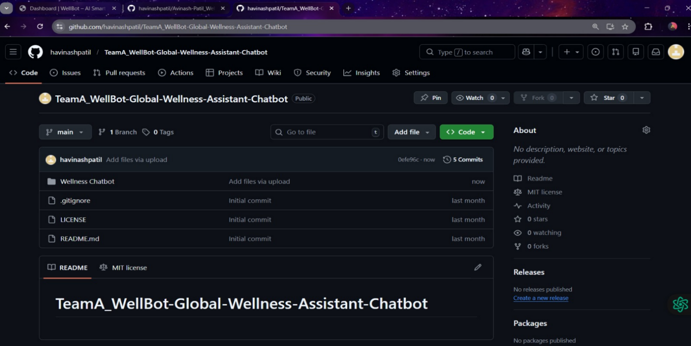

.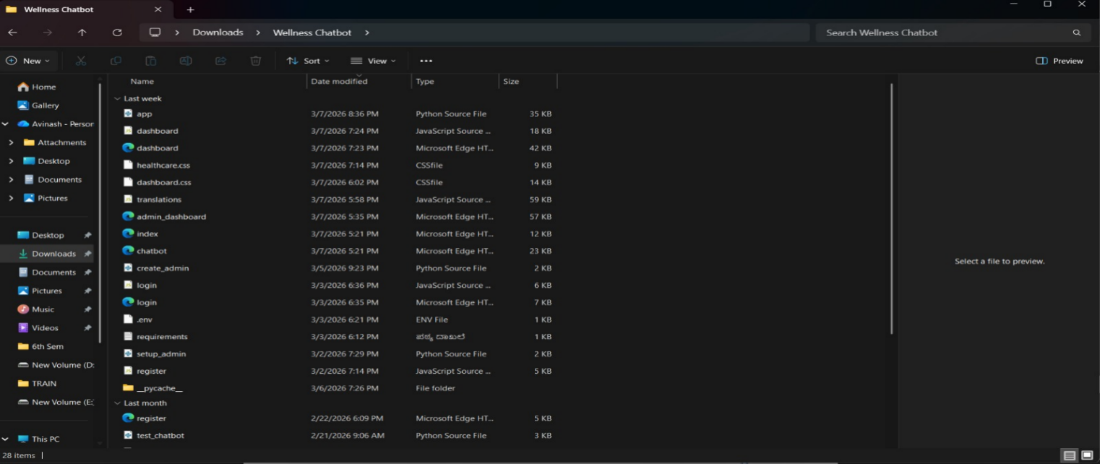
Step 2: Flask backend running locally via python app.py — confirming successful environment setup and API routing.

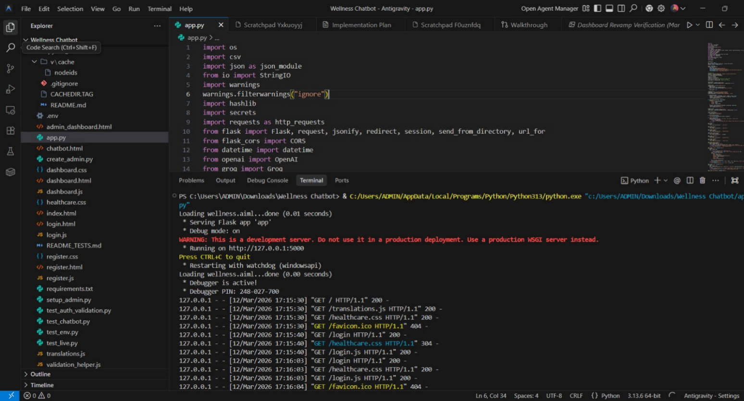

Step 3: WellBot landing page displaying the chat interface with wellness topic shortcuts and navigation.

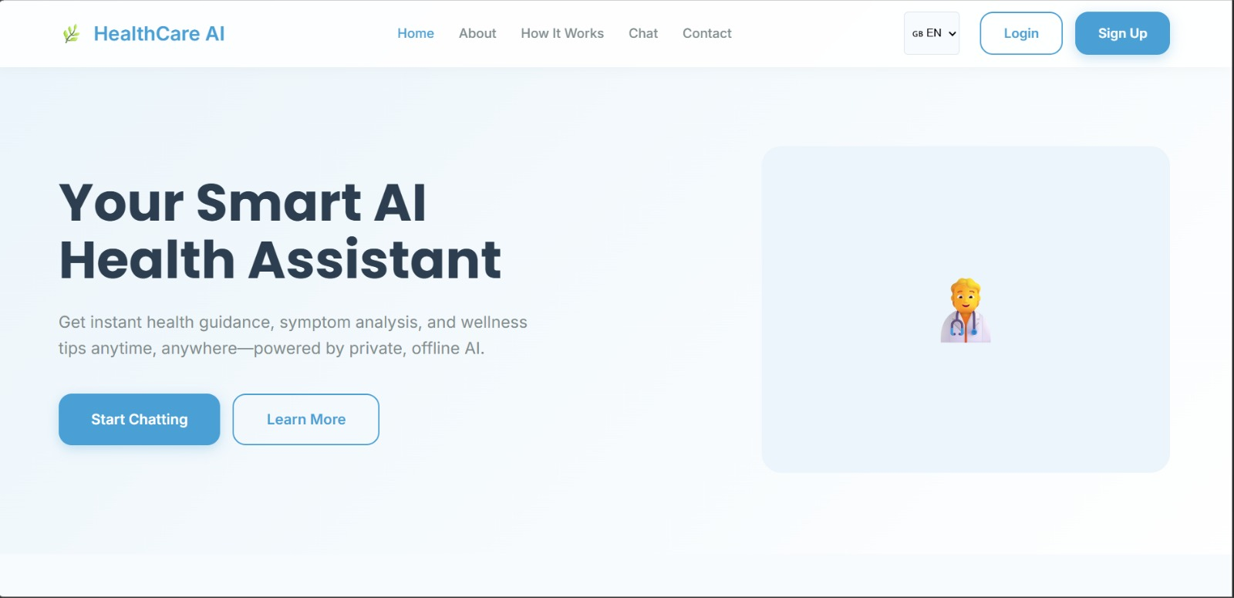

Step 4: User registration and login screens demonstrating secure authentication flow.

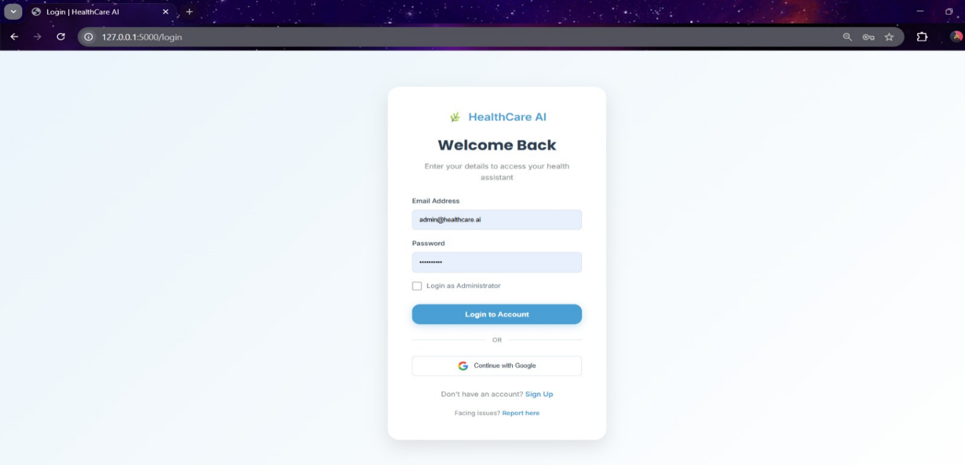

Step 5: Active chatbot session showcasing LLM-powered wellness response to a user health query.

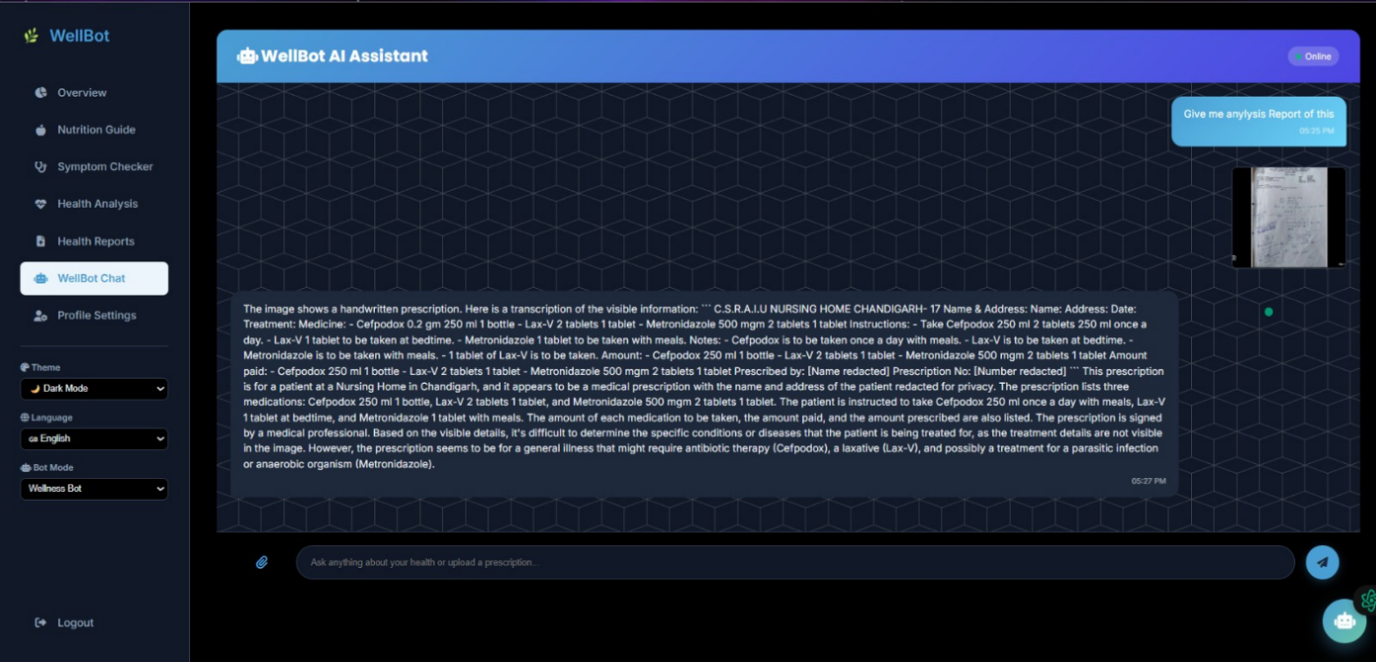

Step 6: Conversation history panel displaying multi-turn session logs.
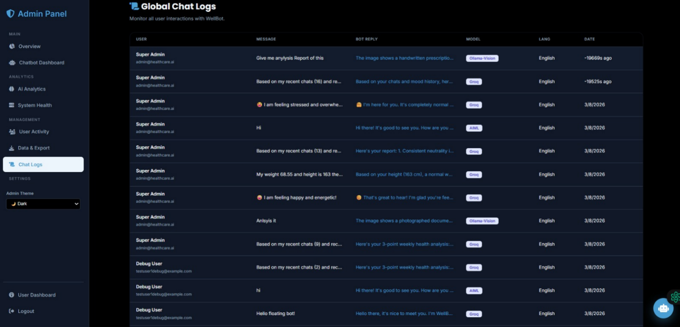
Step 7: Dark mode UI view highlighting theme toggle functionality across the chat interface.

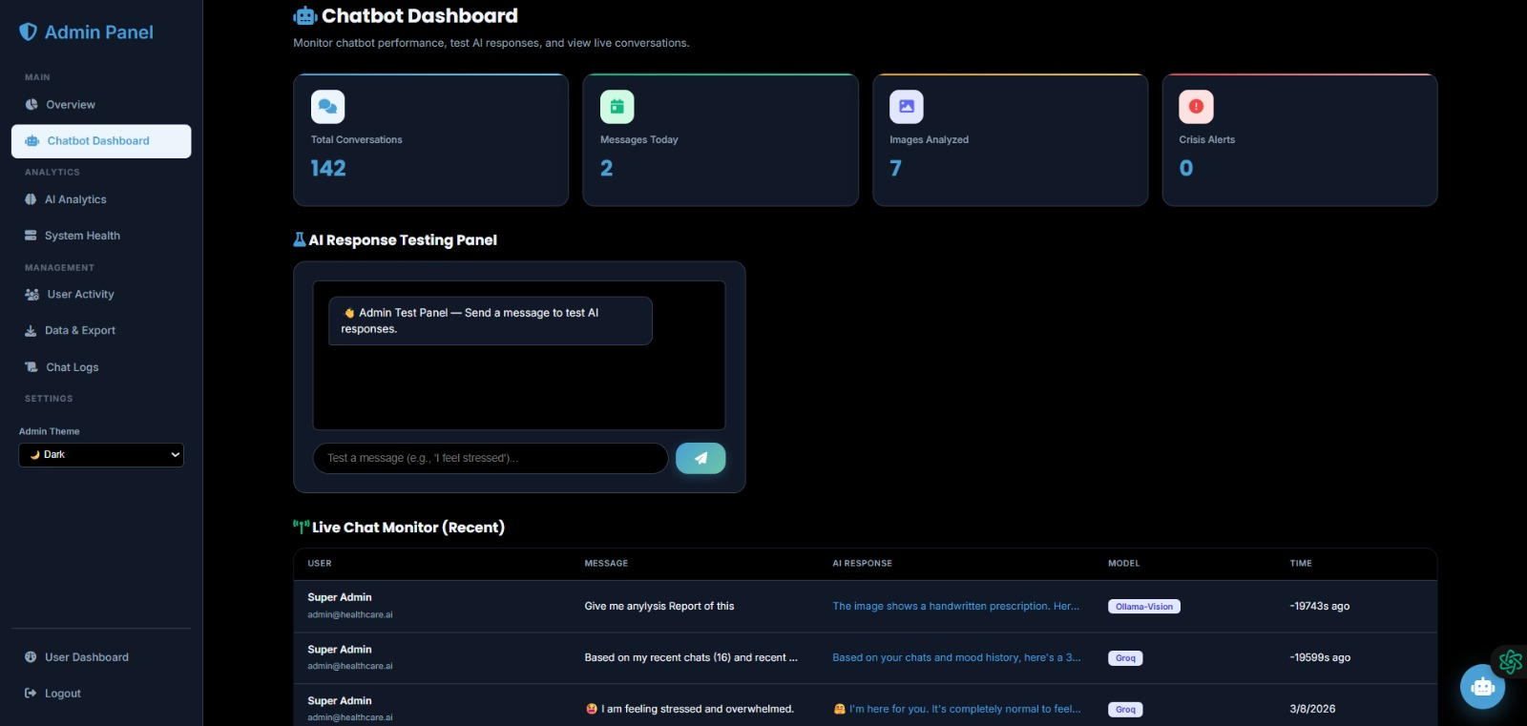

Note: Insert actual screenshots in place of the above captions before final submission.
7. Challenges Faced
During the development of WellBot, several technical and operational challenges were encountered:
- LLM API Rate Limits & Costs: Frequent API calls to OpenAI GPT and Gemini during testing hit rate limits, requiring implementation of request caching, batching strategies, and API key rotation.
- Prompt Engineering Complexity: Crafting system prompts that consistently produced empathetic, wellness-appropriate responses required multiple iterations and careful boundary-setting to avoid off-topic outputs.
- Secure Session Management: Implementing stateless JWT authentication alongside bcrypt password hashing required careful handling of token expiry, refresh logic, and secure storage to prevent vulnerabilities.
- NLP Intent Accuracy: Variations in how users phrase wellness queries led to misclassification. Multiple rounds of keyword mapping refinement and synonym handling were needed to improve accuracy.
- Real-Time WebSocket Integration: Setting up WebSocket support within Flask for real-time chat without performance degradation required careful asynchronous handling and connection management.
- Library Compatibility Issues: Version conflicts among libraries (Flask, PyJWT, NLTK, OpenAI SDK) required environment recreation and careful dependency pinning to ensure stable execution.
- Cross-Cultural Wellness Content: Ensuring that wellness responses were culturally sensitive and globally applicable across different health practices required additional research and prompt tuning.
- Testing Diverse Conversation Flows: Validating chatbot responses across a wide range of wellness topics and user emotional states was time-consuming and required extensive manual review alongside automated checks.
Despite these challenges, iterative debugging, prompt refinement, and systematic testing enabled the team to deliver a stable, empathetic, and fully functional wellness chatbot.
8. Learnings & Skills Acquired
The development of WellBot produced significant technical and professional learning outcomes across the team:
- LLM Integration & Prompt Engineering: Gained practical experience in connecting to OpenAI GPT and Google Gemini APIs, structuring system prompts, and tuning model responses for domain-specific wellness use cases.
- NLP Techniques & Text Processing: Developed hands-on skills in tokenisation, stop-word removal, intent classification, and sentiment analysis using NLTK, SpaCy, and Transformers.
- Secure Backend Development: Learned to implement JWT-based authentication, bcrypt password hashing, and RESTful API design using Flask — building a secure and scalable backend architecture.
- Machine Learning Foundations: Gained foundational knowledge across supervised learning (Linear/Logistic Regression, Decision Trees, KNN), unsupervised learning (K-Means Clustering), and neural networks (ANN).
- Database Design & SQL: Strengthened relational database skills by designing normalised schemas, writing complex queries, and integrating SQL databases with Python backends.
- Version Control & Collaboration: Developed proficiency in Git workflows — branching, pull requests, and conflict resolution — for collaborative multi-developer project management via GitHub.
- Frontend Development & UX Design: Enhanced skills in responsive HTML/CSS interface design, implementing dark/light theme toggling, and delivering clean, user-friendly conversational UI.
- Testing, Debugging & Documentation: Practised unit testing, integration testing, and user acceptance testing, and improved ability to document system architecture, API contracts, and project progress.
Overall, the project strengthened both AI/ML technical competencies and the software engineering mindset needed to build responsible, user-centric AI applications.
9. Testimonials from Team
Team Member – Sameer:
"Working on WellBot gave me a deep appreciation for how LLMs can be responsibly deployed in health contexts. Integrating OpenAI GPT and prompt engineering for wellness responses was a genuinely transformative learning experience."
Team Member – Tejaswini:
"Building the NLP pipeline from scratch — from tokenisation to intent classification — gave me hands-on confidence in text analytics. I now understand how raw user language becomes structured AI inputs."
Team Member – Apeksha:
"Implementing secure authentication with bcrypt and JWT was challenging but incredibly rewarding. WellBot showed me how security must be foundational, not an afterthought, in any AI-powered application."
Team Member – Avinash:
"This project deepened my understanding of how client–server architecture, Flask REST APIs, and WebSocket communication come together. Seeing the full pipeline from user request to LLM response was a defining moment."
Team Member – Sakshi:
"Designing the SQL database schema for multi-user session management taught me the importance of relational data modelling. WellBot made abstract database concepts concrete and meaningful."
Team Member – Harika:
"Contributing to the frontend and dark/light mode UI showed me how much user experience shapes the perception of an AI product. A great model with poor UX fails — WellBot taught me to think holistically."
10. Conclusion
WellBot – Global Wellness Assistant Chatbot successfully demonstrates how Large Language Models, NLP, secure backend engineering, and user-centric frontend design can converge to deliver meaningful, real-world AI value in the wellness domain.
The system delivers personalised, contextually aware health conversations powered by GPT and Gemini APIs, secured by industry-standard authentication practices, and presented through an accessible, responsive interface. Throughout development, the team built genuine expertise spanning AI integration, machine learning, database design, REST APIs, and agile milestone management.
The project validated that responsible AI deployment — where security, empathy, and technical rigour are balanced — is both achievable and impactful. WellBot stands as a scalable, industry-aligned solution with clear pathways for enhancement, including multi-language support, wearable device integration, voice-based interaction, and personalised health analytics dashboards.
Ultimately, WellBot reflects the team's technical growth, collaborative spirit, and commitment to building AI products that genuinely improve human wellbeing.
11. Acknowledgements
We express our sincere gratitude to Infosys Springboard for creating an exceptional learning environment, providing industry-relevant curriculum resources, and trusting us with the opportunity to build a real-world AI application during this internship.
We extend our heartfelt thanks to , our mentor Miss Shakthi Gopalakrishnan, for her invaluable guidance, constructive feedback, and consistent encouragement throughout every milestone. Her support was instrumental in shaping both our technical approach and professional outlook.
We also appreciate the dedication of each team member — Sameer, Harika, Apeksha, Avinash, Tejaswini, and Sakshi — whose collaboration, creativity, and commitment made WellBot a success.
Finally, we are grateful to our faculty, peers, and families for their motivation and support throughout this journey.

